The Anglican Church in Aotearoa,
New Zealand and Polynesia
Te Hāhi Mihinare ki Aotearoa ki Niu Tireni, ki Ngā Moutere o te Moana Nui a Kiwa

JUDICIAL COMMITTEE

Minutes of a Meeting held via Zoom on 17 June 2020 from 7.30pm
Present:
House of Bishops  House of Clergy  Tikanga Māori | Bishop Steven Benford  The Rev’d Joel Rowse  Vacancy  Vacancy
Tikanga Pākehā | Judge Chris Harding (Chair)  Judge Anne McAloon  Ms Brigit Brant
Tikanga Pasefika | Mr Walton Morgan  Ms Mele Taliai
General Secretary | Rev’d Michael Hughes

- WELCOME AND OPENING PRAYER
Judge Chris Harding welcomed all members.
Rev’d Joel Rowse led opening prayer.
- APOLOGIES
Ms Mele Taliai.

3 MATTERS FOR CONSIDERATION
The Committee had received a further submission by the appellant regarding issues of jurisdiction and power to make orders sought.

A discussion followed as to whether the Committee had jurisdiction to hear the appeal. There was unanimous agreement it did.

Moved by the Chair, that the JC accepts it has jurisdiction to hear the case and agrees to do so. Agreed unanimously.

The Committee then considered who needed to be served with application in addition to those claimed by the appellant to be interested. It concluded that those identified by the appellant as interested parties, despite reservations about whether some of those named were in fact practically interested, should be served by email at the addresses provided by the appellant. The Bishops are also required to be served by Title C Canon IV clause 4.3. It considered the Board of Governors and Board of Trustees of Kings College should also be served as additional parties clearly practically interested. Service was determined to be effected by email in each case.

Moved by the Chair accordingly. Agreed unanimously.

The Committee considered an appropriate timeframe within which a response should be required in terms of Title C Canon IV clause 4.3 and concluded that despite the request for interim relief, 28 days was reasonably required to enable those directed to be served to state their cases to the Committee.

Resolved The Timeframe – 28 days for any statement of case, from receipt of email with papers. Form – by email to the Secretary.

The Committee considered what material should be provided to parties being notified and after discussion agreed that in addition to the materials originally provided by the appellant, the Committee’s letter to him of 21 May 2020 and his reply and attachment 12 June 2020 should also be included.

Resolved accordingly.

The Committee agreed to meet again after the time for all responses has passed to determine if the matter may be resolved on the papers, or if a hearing is required and if so to make further determinations as to process and set any further timeframes.

The Secretary is asked to provide notes for Chair to draft minutes and the letter to the parties practically effected.

4 CLOSING PRAYER
Bishop Steven Benford closed with prayer.

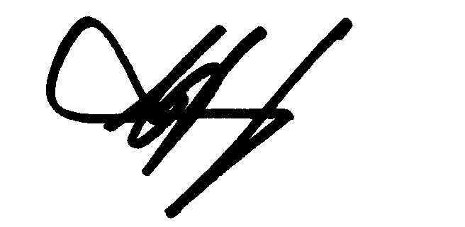
______________________________
C J Harding
Chair

18 June 2020

